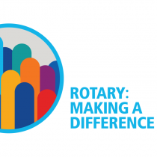
^{Annual Report}
²⁰¹⁸
Rick Fiedorec, President
Adam Jenkins, Treasurer
Michelle Chatten-Fiedorec, Secretary
Bill Egnatoff, Past President
Elizabeth Cohoe
Greta Du Bois-Cleynhens
Patti Enright
Ron Pols
Martin Sherris
Ana Sutherland
Susan Zambonin

Retiring Board Members
Michelle Chatten-Fiedorec
Patti Enright
Adam Jenkins
Martin Sherris

Honourary Members
Sheila Allard
Mike Campbell
Roy Conacher
Wally Donohue
Bob Dowling
Nancy Gray
Marcia Shannon
Terry Wilson
Board of directors

Four Way Test
- Is it the truth?
- Is it fair for all concerned?
- Will it build good will and better friendships?
- Will it be beneficial for all concerned?

Rotary Reflection
For food in a world where many walk in hunger
For peace in a world where many walk in fear
For friends in a world where many walk alone
And for the opportunity to serve others through Rotary, may we be truly thankful!

Acknowledgement of Territory
We are gathered on traditional Anishinaabe and Haudenosaunee Territory. We are grateful to
be able to join together in Rotary Fellowship on these lands.
Message from Rick Fiedorec
President, Rotary Club of Cataraqui-Kingston
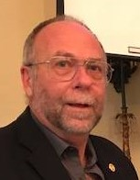

As the 2017-2018 Rotary year draws to an end, I want to thank not only the Board but all members of the Rotary Club of Cataraqui-Kingston for the opportunity and privilege to have been your President. Since joining in 2010, I’ve never felt that Rotary was an obligation and I’m looking forward to the coming year.

It’s been wonderful. Working with people who have a different opinion but the same goal… to make our local, national and international communities better. Your ability to think “outside of the box” has been just awesome to watch.

I believe we have been more adventuresome in choosing grant recipients and yet fiscally responsible with the community’s money. We have broadened our focus to include national and indigenous people…Canadians, in our search for projects. We’ve awakened the membership to the existence of our educational bursary at St. Lawrence College, with plans on taking it further. We have kept youth and food security a priority. We’ve enjoyed having Amanda Molto, youth exchange student from Spain with us and looking forward to the arrival of the Friendship Exchange from South Africa.

Sadly, we will be losing a few members. We had some members who have moved away, as well as the passing away of Colonel Gerald (Gerry) Coady. I miss his “welcome aboard” handshake.

In a few weeks we start a new year and the work we do will continue. The Rotary Club of Cataraqui-Kingston has accomplished much, not only this past year, but also in the past 33 years of existence. We have made a difference.

CK Rotary – By the Numbers
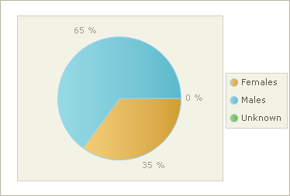
Gender Distribution

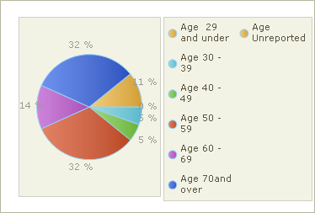
Age Distribution

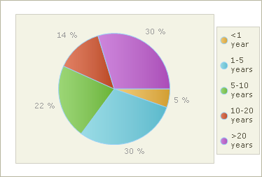
Years of Service

Committees

Club Administration - Ron Pols (chair)
John Farrow, Terry Hicks, Patty LeCollier, Howard Lee and Robert Reid

Membership - Martin Sherris (chair)
Murray Cotton, Rick Frasso, Terri Hodges, Ana Sutherland and Doug Townsend

Communications & PR – Susan Zambonin (chair)
Bill Egnatoff, Rick Frasso, Patty LeCollier, Joe McInerney and Ana Sutherland

Service Projects – Elizabeth Cohoe (chair)
Sub-committees:
Bingo – John Farrow (chair)
International Projects – John Gale (chair)
Community Projects – Terri Hodges (chair)
Regional & National Projects – Robert Reid (chair)
Community Auction – John Richards (chair)
Volunteer Projects – Susan Zambonin (chair)

Foundation – Greta Du Bois Cleynhens
Bernie Allard (Polio Plus), Michelle Chatten-Fiedorec, Robert Reid and Ana Sutherland

New Generations – Patti Enright (chair)
Michelle Chatten-Fiedorec, Bill Egnatoff (Adventures in History), Heather Kembel, Greg Mumford, Sigi Scholten (Youth Exchange)

IT Manager – Bill Egnatoff

Friendship Exchange to South Africa
Twelve Rotarians from four clubs in Kingston and Gananoque participated in a Friendship Exchange trip in October 2017 as organised by the Rotary Club of Cataraqui-Kingston and District 9400 in South Africa.

For two weeks they were hosted in the homes of South African Rotarians, they were transported, visited cultural and natural wonders, attended meetings, saw different projects and enjoyed many fellowship events. They traveled to 4 different regions of District 9400. They became quickly acquainted with daily life in South Africa, the present, the past, and the people of the country. The highlight of the trip was a three-day safari in the bush.

Such Friendship Exchanges foster cooperation between clubs of different countries, involvement in International and local projects and creates strong bonds not only on humanitarian but also on a personal level.

At the end of June, ten South African Rotarians from seven clubs in District 9400 will be hosted by Rotarians in our region as an Exchange Rotary Friendship group

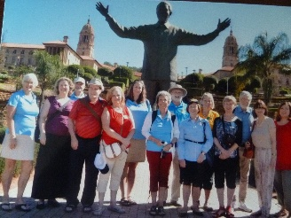
Canadian Rotarians and some South Africans in front of the Nelson Mandela statue in the gardens of the Union Buildings in Pretoria

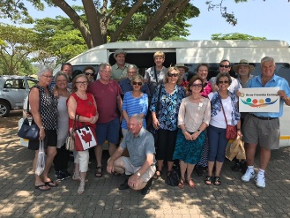
Canadian and South African Rotarians on the road in the province of Mpumalanga

Paul Harris Fellowship were awarded to:
Foundation Committee
- Mada Bender – young activist and mentor to student not fitting into social or school circles
- Claire Bouvier – started Claire’s Closet as a motivational programme for young women entrepreneurs and she is the founder of FEiST (Female Entrepreneurs in Small Towns)
- Erin Petersen – chair of DECA (College & career preparation group) financial literacy for High School students and co-chair for the model UN
- Mara Shaw – driving force behind Loving Spoonful which provides help for low income families & individuals and food security organizations
- Howard Lee
- Murray Cotton
- Heather Kembel
- Ron Pols
- Bill Egnatoff – Paul Harris +1

Special recognition for support of the Rotary Foundation & the Million Dollar Dinner was made to Bill Gray, John Gale, Elizabeth Cohoe, Ana Sutherland and Ed Thomson.

Foundation Walk was held on 12 May 2018. Principal walker representing our Club: Rick Fiedorec, sponsorship brought in $ 273.00 for Rotary Foundation.
Communications & PR

Thanks to Bill Egnatoff and Yana Gursoy we are getting some well-deserved recognition on social media and our new website is almost ready to go live. The committee has purchased a tent to use at community events to help increase our profile.

As we finish off this Rotary year, we can look back at a number of fellowship activities which were enjoyed by all club members:
Club Administration
- Axe throwing event
- Tour de Lac evening at the Portsmouth Tavern was a fun time for all. I am still amazed at the physical condition these cyclists had, cycling over 100 km per day in extremely warm, humid temperatures
- Mess Arts Studio Breakfast was a great opportunity to see what our grant recipients are doing with Rotary assistance
- Billiards night at RAXX Bar and Grill was an opportunity for some ‘experts’ to display their talent with the pool cue
- Kingston Frontenac’s Rotary hockey afternoon vs. Barrie Cots was a fun time enjoyed by all
- Annual Rotary Christmas party was held Tues. Dec 12th
- Going away party at the Portsmouth Tavern for Jane & Norm Neil
- Going away party at RAXX Barr & Grill for Gord Hill

A special thanks to everyone who "dressed up for our Hallowe'en Breakfast – some interesting costumes indeed!

Ongoing Business - John Farrow scheduled guest speakers throughout the year; Howard Lee (our Sgt. at Arms) has been busy co-ordinating our weekly programs, and monitoring our supplies, stationary, etc. The change in breakfast menu was well-received.

Our final celebration is our Year End BBQ: a great way to finish off another successful Rotary year for our club.

Many thanks to a fantastic team in Club Administration
for making this all happen!

Service Projects is all about Rotary Service. It includes fund raising, financial support for community, national and international service projects, and projects we support through our volunteer time. Sometimes we ask members to offer their financial support on an individual basis.
Service Projects

There are four fundraisers, and with all of them, raising money isn’t the only objective.
- Nut drive led by Rick Fiedorec
- Cash Calendars led by Murray Cotton
- Bingo has been led by John Farrow
- 21st Annual Rotary Community Auction was led by John Richards and has grown from a Sunday afternoon TV event with bidding by phone for just short of 200 items, to being completely online

We have re-created a Community Service Committee as a standing committee of the club. (Prior to our instigating the community grants process there was such a committee.) The community grants process will be part of the work of this committee. Terri Hodges, who has been leading the twice-yearly grants adjudication process has some ideas to improve submissions and make it easier to evaluate them. It will also be good to have a committee available to evaluate other situations that may arise, such as a review of our annual financial support in some areas.

This year we supported community projects through our twice-yearly call for grant proposals. Terri Hodges led this process, assisted by Doug Townsend and Richard Dobing, and all club members who were invited to read and evaluate the proposals and attend the adjudication meetings. A summary of our support for recent years can be found on our website.

In addition to money distributed through the grants process, we have some projects that we have been supporting annually. Those are the Salvation Army (for their social aid programs), Lunch by George (which offers hot meals at no cost), and the club currently matches members’ donations to Easter Seals, up to $1,000. This year’s project leader was Joe McInerney. We assist Easter Seals with their fundraising by having members donate on our fundraising page on the Easter Seals website, and some members encourage their friends to do this as well. Honorary member, Terry Wilson has done some fundraising in the community. Our team page raised $4,525, and “matching” money from the club brought it to $5,525.

Regional and National Service
Robert Reid leads this committee. To date, it has focused on the needs of First Nations communities and projects that contribute to reconciliation. Projects will not be restricted to this, but that is where needs have been identified. Currently, several projects are being explored, and will require carrying over some of this year’s budget into next year. An acknowledgement of territory at our meetings is seen as a small gesture of reconciliation, and appears in our Courier weekly.

International Service
John Gale leads the international service committee. This committee meets to discuss projects with a potential for our involvement, and monitors those in which we are already involved. Our club looks at projects that involve multiple clubs and Rotary Foundation grants. Current projects are located in several countries, and the list is long because the process takes a lot of time from start to finish. This past year, a $US account was set up in order to make tracking the committee finances easier. Our internationally designated funds also support Shelter Box Canada, which is an offshoot of the international organization founded by Rotary in Cornwall England.

Volunteer Projects
- Salvation Army Kettles
- The Partners in Mission Food Bank - Food Blitz in which we participated has been led by the Waterfront Club
- Habitat for Humanity house build - member, Greg Mumford, volunteers at the site on a regular basis
- The Lunch by George Christmas Dinner has become an annual event
- Loving Spoonful has been supported in the school gardens and in the Kingston Night Market and adopt a grocery store project
- Skeleton Park Arts Festival
- Kingston Indigenous Medical Aid Initiative
New Generations

Youth Exchange
This year the Club sponsored outbound student Marcel Gummert who is in Cremona, Italy. Marcel sent an email to express his gratitude to the club for the opportunity. Amanda Molto Planells is our student from Valencia, Spain for YEX 2017-2018. Amanda has had a busy year participating on the rowing and rugby teams for Regi. Amanda has also participated in the YEX district events. Amanda and Carina Gummert, our 2016-2017 outbound student, participated in the Polar Bear Plunge, a fundraiser for the Special Olympics.

Adventures in History
With the Kingston Club we sponsored and organized Adventures in History in September 2017. The theme for the program, Doing Time in Kingston: Youth Justice Then and Now has been well received by participants. Thank you to Bill Egnatoff for organizing Adventures in History.

Adventure in Citizenship-May 2018
The Club sponsored Dawson Einarson who reported that it was a life-changing opportunity for him.

Rotary Youth Leadership Academy (RYLA)
This year the Kingston club sponsored RYLA which took place at St. Lawrence College in June. The Club sponsored Farida elsharkaway.

Kingston Regional Heritage Fair
For the second year the Youth Services Committee participated in Community Street at the Kingston Regional Heritage Fair in May. We spoke with more than 130 students who stopped by our booth to try to solve the game provided by Improbable Escapes. It was a great opportunity to raise awareness of Adventures in History and other Rotary programs. The Club also donated $1,000 to help fund the KRHF winners’ attendance at the provincial heritage fair in Toronto.

Special Thanks to our Auction Sponsors

Strategic Benefits & Insurance Services Ltd. / Colbourne & Kembel Architect Inc. / Capital Movers & Storage / Response I.T. / Coral Services / Ontario Power Generation / Robert J. Reid & Sons Funeral Home / Sir John’s Public House / Creative Display / Subaru of Kingston / Kingston Hyundai / Mackillop Law / Homestead / Holway & Hutchinson Insurance Limited / 4 Office Automation / Kwik Kopy Printing / Countrywide Kitchens

Auction Community Supporters

Janati Yoga / Dr. Martin Thomas / Foley & Sutherland Insurance and Financial Services Inc. / Kingston Dodge / Burkom, LeBlanc & Wilcox Investment Advisors / TechActif Cloud Consulting/ Emmons & Mitchell Construction / Richard Strong – CIBC Wood Gundy / Courtyard Marriott Kingston / Reid Properties / Kingston Webworks / Peter’s Drugs / John R. Crouchman / Mike Scrannage / Sims Animal Hospital / Action Flooring / National Bank / Investment Planning Counsel / Fidelity

Meeting location: Renaissance Event Venue, 285 Queen Street, Kingston – Tuesdays at 7:15 am
Mailing Address: P.O. Box 1964, Kingston, ON, K7L 5J7
www.ckrotary.org

